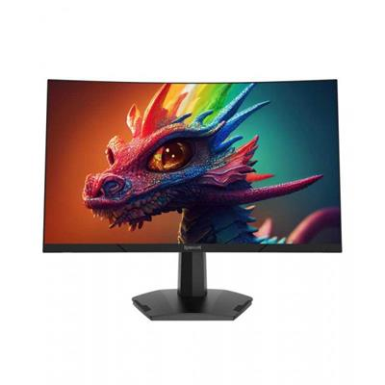

REDRAGON AMBER 27 inch 165Hz Curved Gaming LED Monitor FHD 1ms VA Panel

* Display size: 27" DiagoN/Al LED-Backlight
* Brightness(Typical): 250cd/m2 (Typical)
* NTSC : 90%(DCI-P3)
* Contrast(Typical) : 3000:1 (Typical)
* Active Area(mm): 597.888（H）x 336.312（V）
* Pixel Pitch(mm) : 0.3114(H) x 0.3114(V)

GAMING LED